# CTGuard Mobile Application

Project Documentation Submitted

To the Faculty of School of

Computing and Information Technologies

Of

Asia Pacific College

In Partial Fulfillment of the Requirements for the subject

Applied Projects 2

By

Barriga, Jacques Vincent

Catuncan, Franz Iljah  
De Mesa, Paul Franzchel

Dizon, Dan Patrick

Maraya, Lorina

Mojica, Albert John

Pilares, Dwight Stephen Paolo

Table of Contents

CTGuard Mobile Application 1

Executive Summary 3

List of Figures, List of Tables, List of Notations 4

I. Introduction 5

1.1 Project Context 5

1.2 Purpose and Description 5

1.3 Objectives 5

1.4 Scope and Limitations 5

II. Review of Related Literature/Systems 5

III. Technical Background 5

IV. Methodology, Results and Discussion 5

4.1 Requirements Analysis 5

4.2 Requirements Documentation 5

4.3 Design of Software, Systems, Product, and/or Processes 5

4.4 Development and Testing, where applicable 5

4.5 Description of the Prototype, where applicable 5

4.6 Implementation Plan (Infrastructure/Deployment) where needed 5

4.7 Implementation Results, where applicable 5

4.8 Include discussion on conceptual design / system architecture/ block diagrams and algorithms 5

V. Conclusions and Recommendations 5

VI. Appendices 5

# Executive Summary

CTGuard is a mobile application with a purpose of lessening criminal incidents that involve public utility drivers particularly of taxis. Through the app, users can alert authorities of imminent distress with a push of a button.

We target to build a mobile application about safety commuting that can help passengers report abusive drivers that they may encounter.

Unpleasant situations such as overcharging, physical and verbal abuse, rape, kidnapping and murder are one of the many facets that hinder a commuter safe society. Even during the past administrations, it is evident that safety in mass transportation has and is still a lingering problem in the country considering that there are still similar incidents happening at present.

# 

# List of Figures, List of Tables, List of Notations

# Introduction

## Project Context

## CTGuard Mobile Application is a safety commuting application which can help passengers immediately report abusive PUV Drivers they may encounter. Summary features of the application includes QR Code Scanning, Live tracking and route analysis, Transport identification, Pick-up and Destination Point Analysis, Distress feature and Complaint function.

## Purpose and Description

CTGuard is a mobile application with a purpose of lessening criminal incidents that involve public utility drivers particularly of taxis. Through the app, users can alert authorities of imminent distress with a push of a button. The app also allows users to stay connected with close friends and relatives through its live tracking module. With CTGuard, commuters will feel safe and secure as they commute around the city.

## Objectives

**General Objective**

* CTGuard Mobile Application is a safety commuting application which can help passengers immediately report abusive PUV Drivers they may encounter

**Specific Objectives**

* To enable passengers to report abusive PUV Drivers
* To enable passengers to report violations they have encountered
* Give commuters ability to inform their desired contacts where they are going, what taxi they are riding and to track their current location.
* To let commuters experience a safer and more efficient travel experience

## Scope and Limitations

**Scope of Initial Release:**

* QR Code Scanner – to ensure the safety and sense of security of our commuters, the application will be equipped with a QR code scanning function to fetch identifying details of the vehicle the commuter is in.
* Automatic loading of local contacts – with regards to convenience, the application will do the task of fetching the commuter’s contacts for him/her.
* Google Maps Navigation – the application will help the commuter pick a destination as well as know what routes to be taken so as to avoid being taken to unfamiliar places by potentially abusive drivers.
* Distress Feature – with the simple push of a button, the application will contact 911 as well as the commuter’s selected contacts and will state that he/she is in danger accompanied by his/her current coordinates that constantly update
* Complaint function – should the commuter’s trip involve anything unpleasant with regards to the driver’s conduct or that of another encountered along the way, he/she can file a complaint with a single push that will be sent directly to the proper authorities (LTFRB)

**Constraints and Limitations**

* Mobile Data – Mobile Data is dependent on Data subscription and the Telco’s Data speed
* SMS transmission – SMS delay is dependent to the telco’s signal availability in the area
* Sound Quality of Calls – Quality of Calls is dependent to the Mobile Device’s Signal strength
* Video and/or Audio quality – Quality is dependent to the mobile device’s Video and audio recording capabilities
* App response – performance is dependent on the mobile device’s specifications (i.e., processors, RAM) and operating system
* GPS tagging accuracy – accuracy is dependent on mobile device’s location and proximity from the nearest satellite
* API to Database Communication – Transmission speed between the API and Database cannot be controlled.

# Review of Related Literature/Systems

# Technical Background

* Include in-depth discussion on relevant technical aspects of the project

# Methodology, Results and Discussion

Software Requirements Specifications   
Output

* The Google Maps API must correctly display the coordinates of a user starting from the scanning of the vehicle's QR Code to the conclusion of his/her trip
* The Report Button, once pressed, must display correct data from the applciation and prompt the user to input certain field (seen below)

Application-Based - vehicles plate number and its operator, date User-Based - complaint type data

* The distress button, once pressed, must correctly send details to the primary law enforcement entity (911) and to selected contacts of the user;

TO CONTACTS – current coordinates and a description that he/she is in danger TO LAW ENFORCEMENT – launch a phone call

* The End Trip button, once pressed, must conclude the trip of the user by terminating all live tracking activities and returning to the main page
* Upon selecting a destination point on the Google Maps canvas via touch, the application must notify the user’s selected contacts that he/she is travelling from her current position to the selected point and must enter the “begin trip” state
* Upon pressing the Contacts button, the application must display all local contacts of the user

Input

* User must register in the application.
* User will select desired contacts for the application.
* Each input form must include Qr code that includes information about location, contact number of the driver and the user.
* Qr code must be scan or must be entered in the application.

Process

* User logins to the application
* The application should not allow any new trips from a device while the another device with the same account is in active trip.
* User indicates a destination point
* User scans the QR Code inside the vehicle
* Users sends information (destination point and vehicle information) to chosen contacts
* If in danger, user can press the distress call button. Therefore, calling 911.
* If user has a complaint, user presses the report button, application auto-fill information such as Vehicle’s plate number and its operator and user fills out further details the report.
* User ends trip by either arriving to the destination or tapping the end trip button.

## Description of the Prototype

**Register**

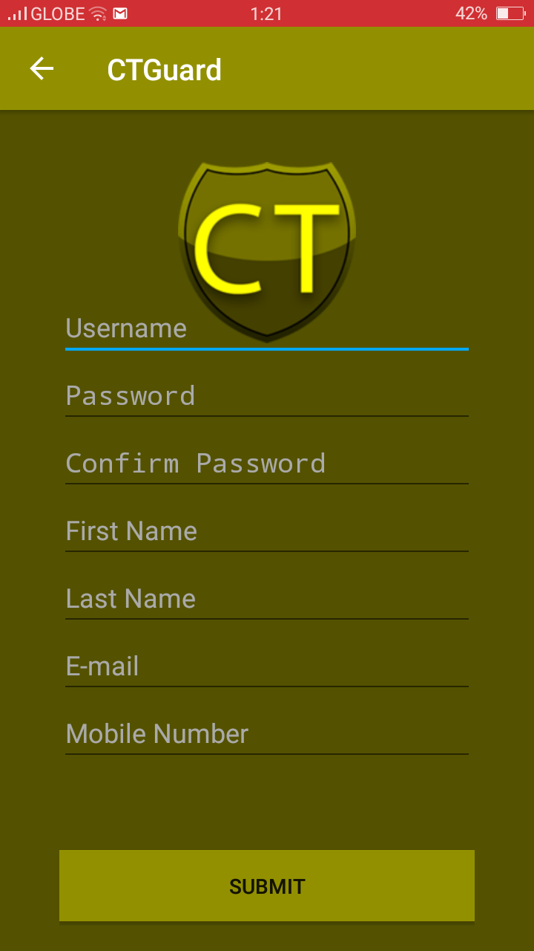

**Login**

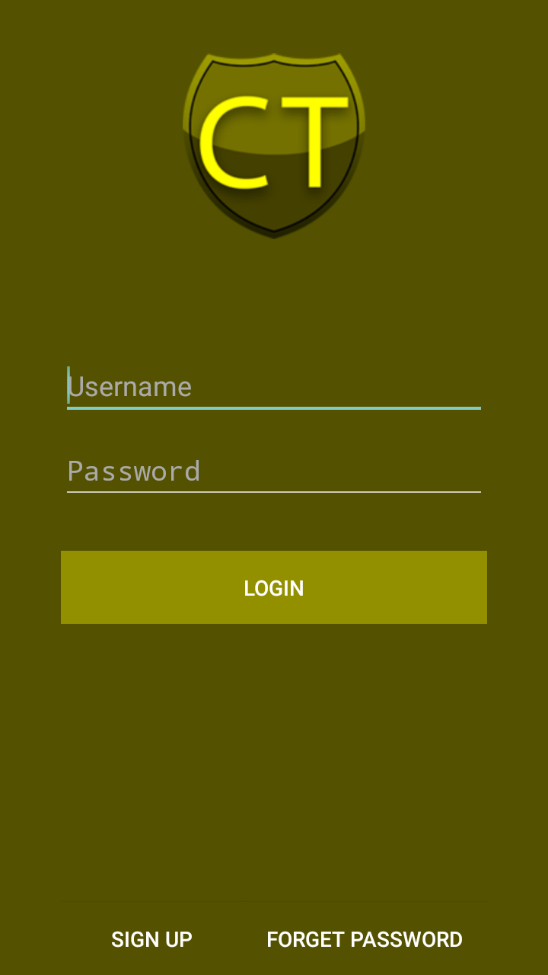

**Home Page upon Login**

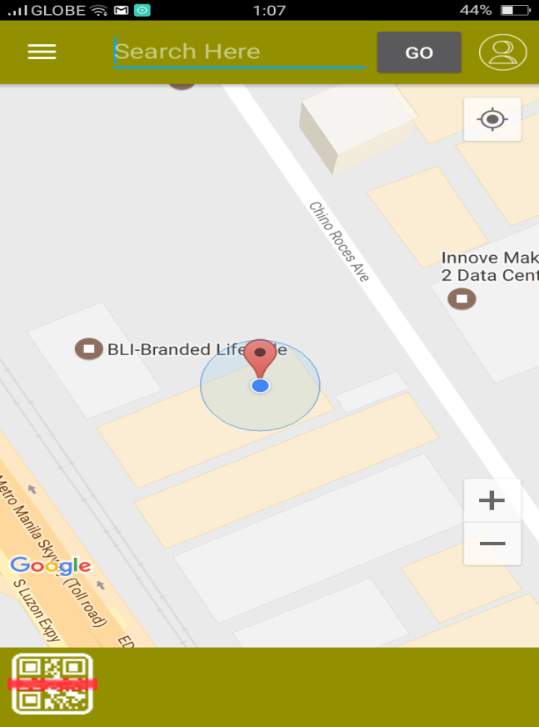

**Homepage after scanning or set destination**

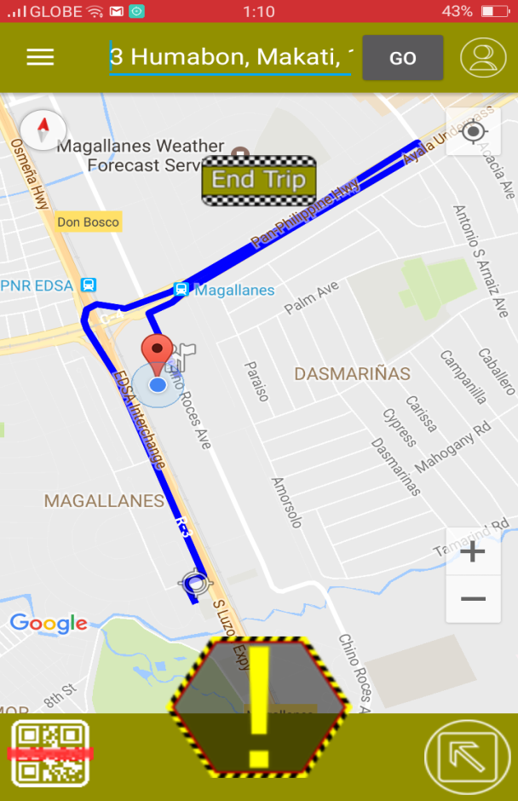

**Distress Button**

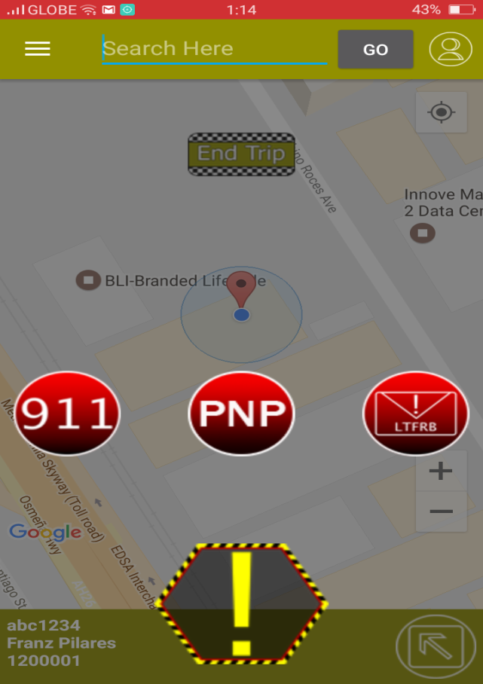

## Implementation Plan (Infrastructure/Deployment) where needed

The CTGuard will be implemented in DILG to give a tracking system to help the commuters have a safe commuting experience. This description of the implementation will provide all stakeholders with a detailed understanding of how the implementation will occur Upon completion of the application, an alpha version will be released to the public. The step by step procedure of this application will be like this First the user will scan the QR Code and then the application will capture the information of the cab and will be sent to the respective contact. The contact will have an option to track the user. The user have a choice whether to file a complaint or not depending on the situation.

## Implementation Results, where applicable

## 4.7 Include discussion on conceptual design / system architecture/ block diagrams and algorithms

# Conclusions and Recommendations

The team's project will provide an application for smartphones that enables to scan a QR Code of a Taxi and obtain its details which you can send to your contact lists. This app also enables the passengers chosen contacts to track them in realtime. If a danger or complaint exits, the app will be able to call local officials for emergency or the user will be able to file a complaint about the driver and its operator.

# Appendices

Event Table

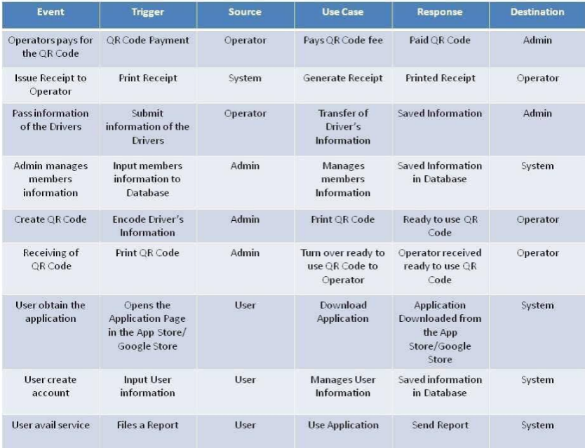

**Use Case Diagram**

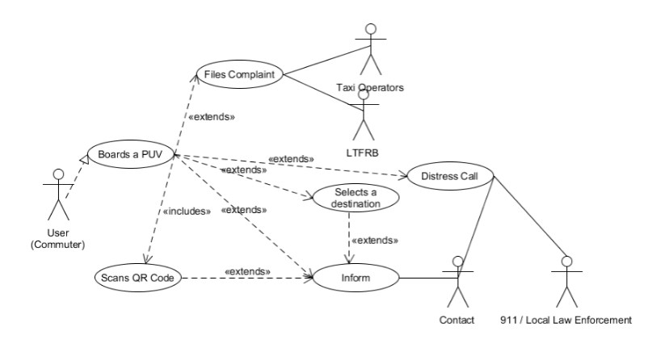

**Use Case Full Description**

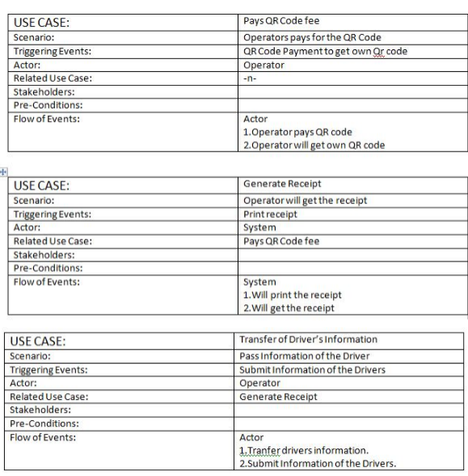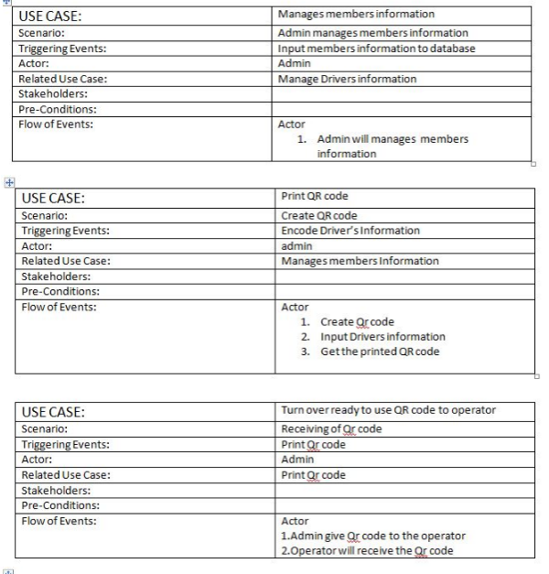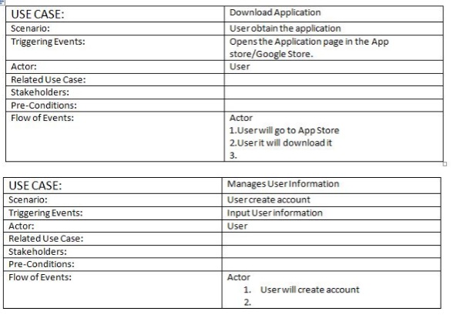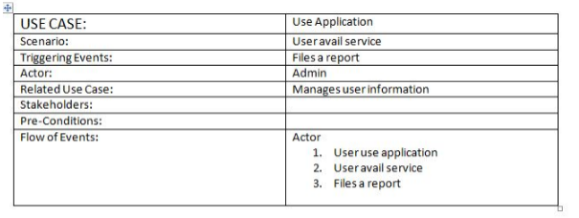

**Context Flow Diagram**

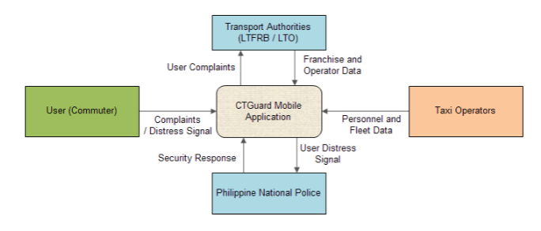

**Data Flow Diagram**

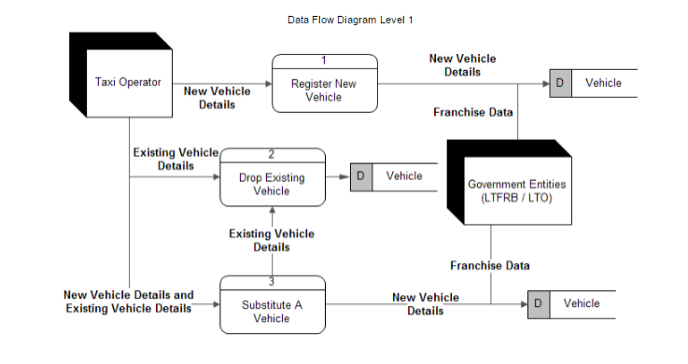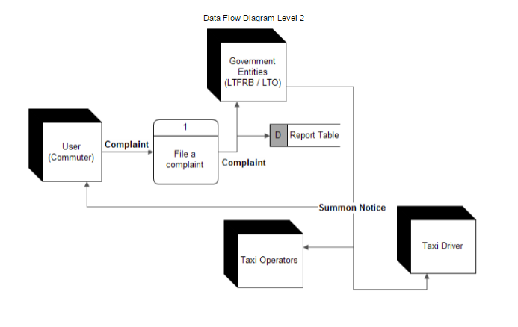

**Sequence Diagram**

